Wenjie

Wireshark Lab 1 – Intro

1. What is the Internet address of your computer?

Answer: My computer Internet address is 192.168.1.4

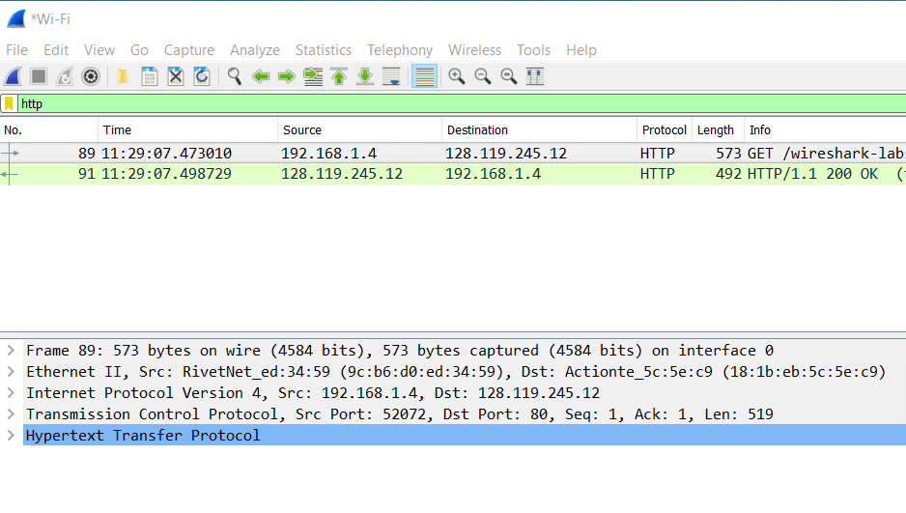

2. List 3 different protocols that appear in the protocol column in the unfiltered packet-listing window in step 7 above.

Answer: The three protocols are QUIC, TCP, DNS.

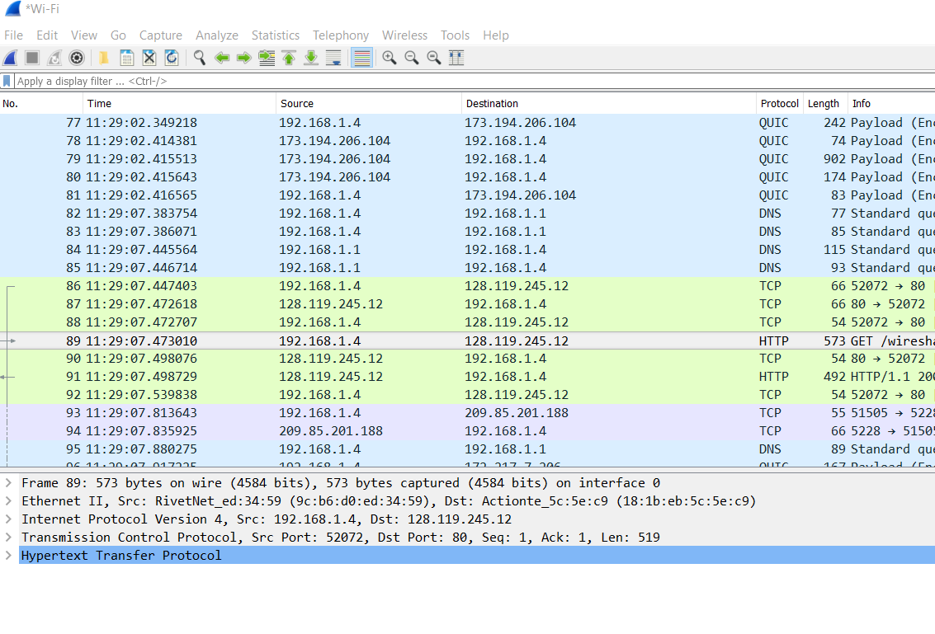

3. How long did it take from when the HTTP GET message was sent until the HTTP OK reply was received?

Answer: The GET was sent at 11:29:07.473010 and Reply was received at 11:29:07.498729. So, it took 0.025719secs.

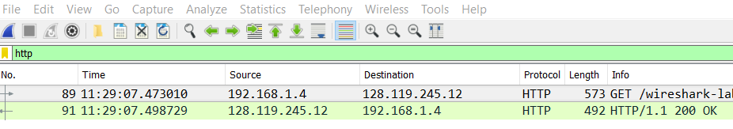

4. What is the Internet address of the gaia.cs.umass.edu (also known as wwwnet.cs.umass.edu)?

Answer: The Internet address of the gaia.cs.umass.edu is 128.119.245.12



5. Print the two HTTP messages (GET and OK) referred to in question 2 above. To do so, select *Print* from the Wireshark *File* command menu, and select the “*Selected Packet Only”* and *“Print as displayed”* radial buttons, and then click OK.

Answer:

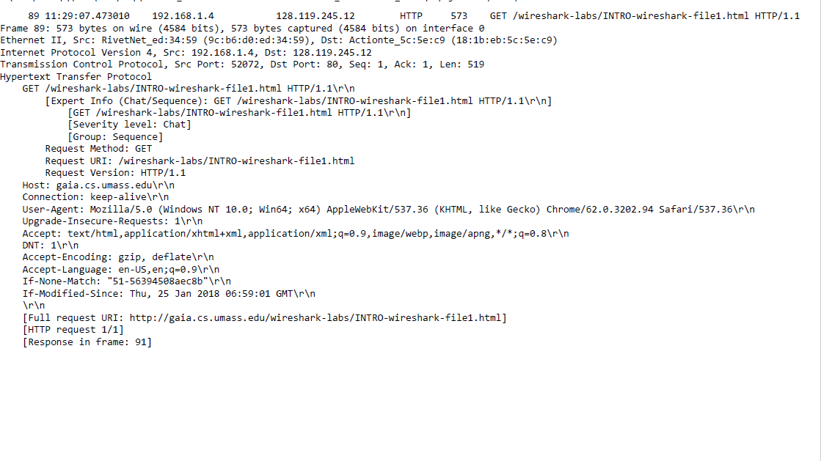HTTP GET message:

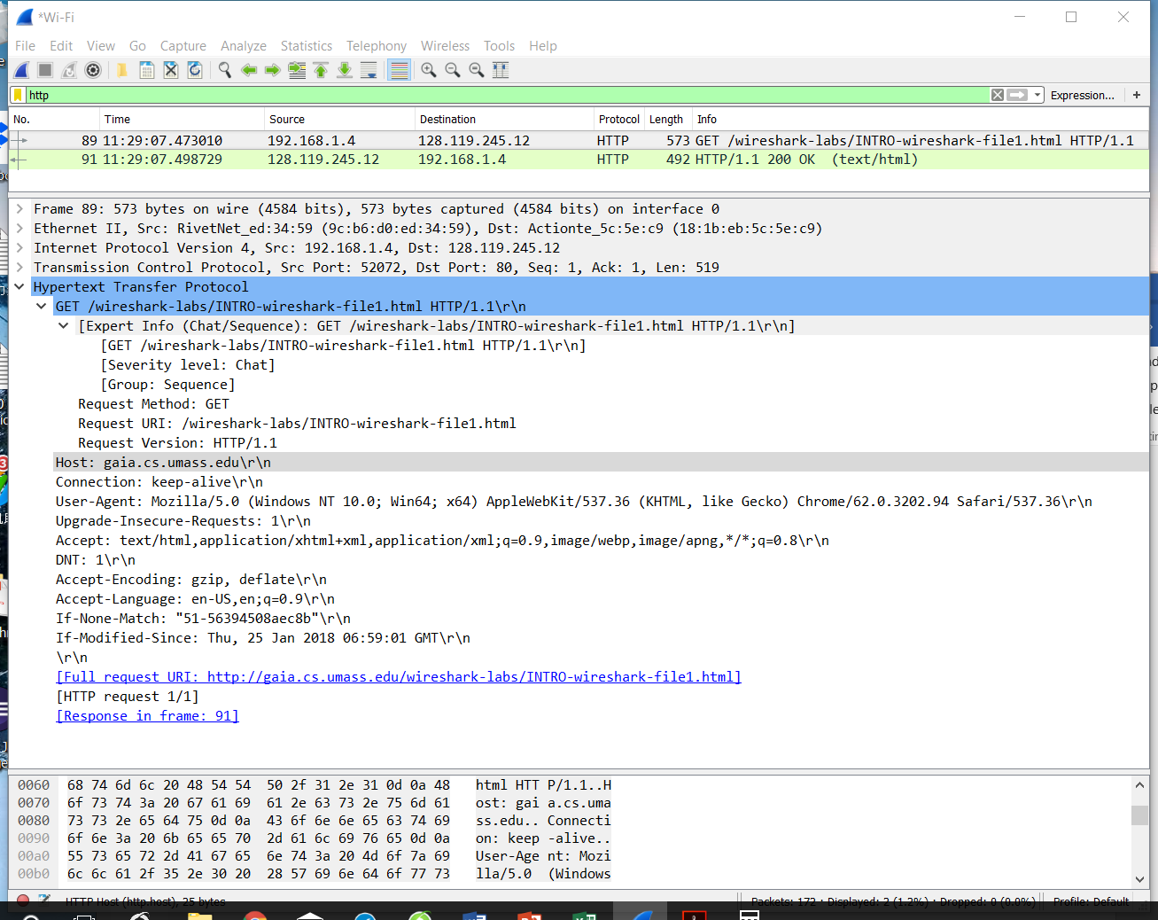

HTTP REPLY message:

